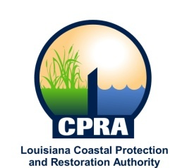
2015 Public Meeting

Coastal Protection and Restoration Financing Corporation

Mon, Oct 19, 2015 -- 10:00 a.m.

State Capitol

4th Floor Governor's Press Room

900 North Third Street

Baton Rouge, La 70802

Contact:

225-342-3968

